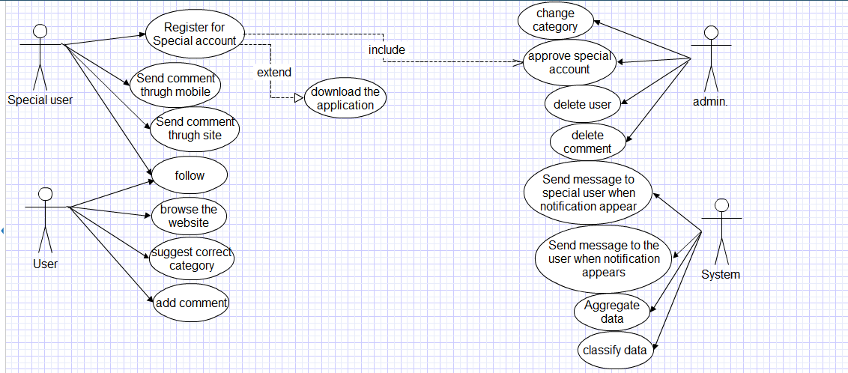**The use case**

**The Scenario**

***Actors:-***

1-Special user.

2-user.

3-Admin.

4-System.

***Functions:-***

1**-**Register for special user.

2-Send comment through website.

3-add comment through mobile.

4-Browse the website.

5-follow.

6-Suggest correct category.

7-add comment.

8-change category.

9-approve special user.

10-Delete user.

11-Delete comment.

12-send notification in SMS.

***1-Register for special user:***

* **The actor:** Special user.
* **Post condition**: the user has an account.
* **Flow of events:**

1-VIP register through the website.

2-Admin approves the account.

3-the user can download the mobile application and use it.

**2*-Send comment through mobile:***

* **The actor**: Special user.
* **Precondition**: the user has his own mobile application and has VIP account.
* **Flow of events:**

1-login through the mobile application.

* If he login successful: then

2-choose the news he want to comment.

3-write comment

4- Confirm it for publishing.

* If login false: then

The user will browse the site or make new account.

**3-add comment through website:**

* **The actor:** Special user.
* **Precondition:** 1- the user has VIP account

2-the user must login.

* **Post condition:** the comment published on website.
* **Flow of events:**

1-login through website.

* If he login successful: then

2-choose the news he want to comment.

3-write comment

4- Confirm it for publishing.

* If login false: then

The user will browse the site or make new account.

**4-follow:**

* **The actor:** user and special user.
* **Precondition:** 1- the user has user account

2-user must have VIP account for the person he wants to follow.

* **Flow of events:**

1-the user login to his own account.

2-choose VIPs who want to follow

3-choose whether receive notification when VIP’s news appear or when VIP comment.

***5-Suggest correct category***

* **The actor**: user.
* **Precondition**: has user account
* **Post condition:** the rate of selected category increase.
* **Flow of events:**

1-the user login to his own account.

2-select the news he want to move.

3-choose the correct category.

***6-add comment***

* **The actor:** user.
* **Precondition:** 1-VIP allows users to comment.

2-the user is login.

* **Post condition:** comment added.
* **Flow of events:**

1-The user login in his account.

2-add comment to the news which VIP is commented on.

**7-change category**

* **The actor:** Admin.
* **Precondition:** specific number of suggestions from users to change the category of this news.
* **Post condition:** the news moved from category to another category.
* **Flow of events:**

1-the admin login.

2-check number of suggestions from users to move the news to correct category.

3-if the number of suggestions reach to specific number, then the admin will move the news to correct category.

**8-approve special user:**

* **The actor:** Admin.
* **Precondition:** user must make registration for special account.
* **Post condition:** the user have special account just for him.
* **Flow of events:**

1-the admin login.

2-check if special users make registration.

3-approve special user.

**9-delete user:-**

* **The actor:** Admin.
* **Post condition:** number of users will decrease.
* **Flow of events:**

1-the admin login.

2-admin will delete the user

**10-delete comment:-**

* **The actor:** Admin.
* **Flow of events:**

1-the admin login.

2-admin will delete the comment.

**11-Send message to special user when notification appear:-**

* **The actor:** System.
* **Precondition:** new news published related to special user.
* **Flow of events:**

1-system check whether there is new news publish related to special user.

2-search for the special user which the news related on.

3-send message on the mobile application to this special user to add his comment.

**11-Send message to the user when notification appears:-**

* **The actor:** System.
* **Precondition:** new news published related to special user he followed.
* **Flow of events:**

1-system checks whether there is new news publish related to special user.

2-search for users who followed this special user.

3-send message on the mobile application to these users.

**12- Aggregate data:-**

* **The actor:** System.
* **Precondition:** new news published.
* **Flow of events:**

1-Search for the published news about that special users and other news in other sites.

2-the system aggregate the all news that is published about anything or anyone

**12- Classify data:-**

* **The actor:** System.
* **Precondition:** the published news in other sites is aggregated
* **Flow of events:**

1-system checks the aggregated news.

2-system checks the concept of each new.

3-system classify the new In accordance with the category that related to it